**UGANDA CHRISTIAN UNIVERSITY**

**FACULTY OF ENGINEERING, DESIGN AND TECHNOLOGY**

**DEPARTMENT OF COMPUTING AND TECHNOLOGY**

**CS3101 - SOFTWARE PROJECT MANAGEMENT**

**Take home assessment Deadline: 30th Dec.5PM**

**Question One**

1. I. Define a statement of work and outline the work products of your course project.

A Statement of Work is defined as a narrative description of products or services or results to be delivered by that project. The definition of statement of work can be construed to indicate merely the products and services to be supplied to the customer. However, it should also include the contractor's needs and requirements in order to properly deliver the products and services.

I currently have no project but these are the work products of my previous idea;

* Requirements
* Training
* Data
* Testing
* Inspection
* Connection
* Installation
* Construction
* Design
* Technical components
* Market research

1. II. Elaborate 5 potential risks likely threatening your project and how to they can be mitigated.

1. Scope creep

Scope risk, also known as scope creep, occurs when the initial project objectives aren’t well-defined. It’s important to communicate your project roadmap with stakeholders from the beginning and hold firm to those parameters. If you don’t communicate your project scope effectively, stakeholders may try to change requirements mid-project.

How to mitigate scope creep: Creating clear project parameters from the start will strengthen your project scope. Agreeing upon the project scope and communicating that vision with stakeholders from the beginning will leave less room for scope creep. Scheduling regular progress check-ins can also ensure the project stays in line with the original project scope.

2. Low performance

Performance risk occurs when the project doesn’t perform as well as initially expected. While you can’t always identify the root cause of low performance, you can identify project risks that may lead to low performance and look for ways to prevent those risks. Examples of these risks include a time crunch and miscommunication among team members.

How to mitigate low performance: Anticipating potential performance risks early on in the planning process can help you prepare. Using project management software lets you follow your processes in real time, plan your project thoroughly, and promote open communication between team members.

3. Time crunch

Time risk, also known as project schedule risk, is the risk that tasks in your project will take longer than expected. Delayed timelines might impact other things like your budget, delivery date, or overall performance. This is a common risk that you may run into as project manager. When you’re not doing the work yourself across lots of moving pieces, it’s easy to underestimate the time it’ll take team members to complete a project during the initial planning phase.

How to mitigate a time crunch: To mitigate time risk, a rule of thumb is to overestimate the time needed to complete tasks in the planning phase and build in time contingency. That way, you’ll have wiggle room for scheduling later on. You can also create a project schedule using a Timeline or Gantt chart. Having clarity into work, dependencies between work, and any delays can help project managers dynamically adapt to time risk as it crops up. Understanding your project lifecycle can also help you determine how long each task will take.

4. High costs

Cost risk occurs when your project goes over the budget you initially set. Cost risk can occur because of unrealistic or lack of detailed budgeting in the project planning phase. For example, you may feel confident that your project will be completed under-budget. However, creating a detailed list of every project element and what they cost can help you anticipate project needs.

How to mitigate high costs: To mitigate cost risk, estimate each element of your project accurately and stick closely to your budget. The best way to stick to your budget is to create a project plan template to align on deliverables, scope, and schedule. When your project goes into development, consider scheduling regular check-ins to review your budget and how you’re pacing.

5. Stretched resources

Resource risk occurs if you don’t have enough resources to complete the project. Resources may include time, skills, money, or tools. As a project manager, you’re responsible for the procurement of resources for your team and communicating with your team about the status of resources. Resource allocation should happen early in the project planning process, typically 1-2 months before project execution, depending on project size.

How to mitigate stretched resources: The best way to mitigate resource risk is to create a resource allocation plan. A resource allocation plan makes the best use of team resources while maximizing resource impact and supporting team goals. When you know what resources you need from the beginning, you minimize the chance of running out of resources later.

6. Operational changes

Operational risk involves changes in company or team processes, like an unexpected shift in team roles, changes in management, or new processes that your team must adjust to. These things can create distractions, require adjustments in workflows, and may impact project timelines.

How to mitigate operational mishaps: You can’t predict or prevent all operational risks, but if you know a team shift or process change is coming, you can mitigate the effects of the transition. Make sure your team is prepared for the change and has time to adjust through team meetings, scheduling tools, or additional trainings.

1. III. Explain the five stages of your project.

1. Project initiation

Initiation is the formal start of a project. It usually begins with the issue of a projectmandate which briefly describes the purpose of the project and authorizes budget spend.

At this stage, I defined the project at a broad level. I began with a feasibility study by evaluating the problem and determining if the project will solve it. After I decided to undertake the project, this is the foundation of your project and a critical reference point for the next stages. Key components of your PID should be:

* project goals, scope and size
* project organization (defining the 'who, why, what, when and how' of the project)
* project constraints
* project risks
* stakeholders
* project controls and reporting framework
* the criteria for closing and assessing the project

2. Project definition and planning

Project planning is key to successful project management. This stage typically begins with setting goals. The two most common approaches include:

At this stage, I defined the project scope, and developed a project plan and work breakdown schedule. This involves identifying:

* time, cost and resources that are at your disposal
* roles and responsibilities for the project
* quality
* milestones
* baseline performance measures
* progress checkpoints
* risk and resources for resolving unforeseen issues

3. Project launch and implementation

Implementation (also called project execution) simply means putting your project plan into action. It often begins with a project 'kick-off meeting'.

Since my project is yet to be accepted, during this phase, I will carry out the tasks and activities from your project plan to produce the project deliverables. For example, when I am creating early deliverables, I might be tasked to gather product information and prices, and complete all of my product prototyping.

I will have to direct this work by:

* overseeing a team
* managing budget and resources
* communicating to stakeholders

4. Project monitoring and control

Monitoring and control often overlap with execution as they often occur at the same time. They require measuring project progression and performance, and dealing with any issues that arise from day-to-day work.

The use of key performance indicators will determine if my project is on track. This is the time when adjustments may be made on the scheduling of the project. Measurable aspects may include, for example:

* if the project is on schedule and budget
* if specific tasks are being completed
* if issues are adequately addressed

5. Project close

During this last phase, I will complete my work and dissolve the project. Closure doesn't necessarily mean success, but simply the final point of the project. For example closure can happen when I cancel the various project failures.

Project closure often involves things like:

* handing over the deliverables
* releasing staff and resources
* archiving or handing over any relevant project documents
* cancelling supplier contracts
* completion of all activities across the project
* preparing the final project budget and report
* handover into business as usual if this applies

1. IV. Is your project objective driven or product driven, elaborate on the difference.

My project is objective driven because the project is based on the objective of trying to solve an ongoing problem within the current system.

In Product Driven Projects, the base problems are identified and only have to develop a previously determined or designed product. That means only the implementation part of the project is remaining whereas in object driven projects the main objective of the final outcome is considered but doesn’t take much effort to build the finalized fully functioning expected version at the initial iteration. Incremental approach is considered until the final objective is accomplished.

**Question Two**

1. I. Explain the Agile Methods

The Agile methodology is a way to manage a project by breaking it up into several phases. It involves constant collaboration with stakeholders and continuous improvement at every stage. Once the work begins, teams cycle through a process of planning, executing, and evaluating. Continuous collaboration is vital, both with team members and project stakeholders.

Agile's four main values are:

* Individuals and interactions over processes and tools
* Working software over comprehensive documentation
* Customer collaboration over contract negotiation
* Responding to change over following a plan

Agile project management

It’s a process for managing a project that involves constant collaboration and working in iterations. Agile project management works off the basis that a project can be continuously improved upon throughout its life cycle, with changes being made quickly and responsively. Agile is one of the most popular approaches to project management due to its flexibility, adaptability to change, and high level of customer input.

Agile methodologies frameworks. Agile project management is not a singular framework rather; it can be used as an umbrella term to include many different frameworks.

1. II. Draw a product break down structure for your project

|  |  |  |  |  |  |  |  |  |  |  |  |  |  |  |  |  |  |  |  |  |  |  |  |  |
| --- | --- | --- | --- | --- | --- | --- | --- | --- | --- | --- | --- | --- | --- | --- | --- | --- | --- | --- | --- | --- | --- | --- | --- | --- |
|  | **MILESTONES** | **Start (Date)** | **End (Date)** | **Duration (Days)** |  | | | | | | | | | | | | | | | | | | |  |
|  |  |  |  |  |  |
|  | **IDEATION** | 01-01-23 | 30-01-23 | 29 |  |
|  | *Gather Data* | 01-01-23 | 14-01-23 | 13 |  |
|  | *Create Charts* | 15-01-23 | 17-01-23 | 2 |  |
|  | *Create Budget* | 18-01-23 | 20-01-23 | 2 |  |
|  | *Write Proposal* | 21-01-23 | 31-01-23 | 10 |  |
|  | **PROJECT INITIATION** | 01-02-23 | 14-02-23 | 13 |  |
|  | *Creating my team* | 07-02-23 | 14-02-23 | 7 |  |
|  | **PROJECT PLANNING** | 15-02-23 | 28-02-23 | 13 |  |
|  | *Define Requirements* | 20-02-23 | 28-02-23 | 8 |  |
|  | **PROJECT EXECUTION** | 01-03-23 | 31-03-23 | 30 |  |
|  | *Design and Prototyping* | 01-03-23 | 14-03-23 | 13 |  |
|  | *Software Development* | 15-03-23 | 30-03-23 | 15 |  |
|  | *Testing* | 01-04-23 | 15-04-23 | 14 |  |
|  | *Implement* | 16-04-23 | 29-04-23 | 13 |  |
|  | **PROJECT CLOSURE** | 30-04-23 | 30-04-23 | 0 |  |
|  |  |  |  |  |  |
|  |  |  |  |  |  |
|  |  |  |  |  |  |
|  |  |  |  |  |  |
|  |  |  |  |  |  |
|  |  |  |  |  |  |
|  |  |  |  |  |  |
|  |  |  |  |  |  |
|  |  |  |  |  |  |  |  |  |  |  |  |  |  |  |  |  |  |  |  |  |  |  |  |  |
|  |  |  |  |  |  |  |  |  |  |  |  |  |  |  |  |  |  |  |  |  |  |  |  |  |
|  |  |  |  |  |  |  |  |  |  |  |  |  |  |  |  |  |  |  |  |  |  |  |  |  |

1. III. Draw the product flow diagram and the derived activity network

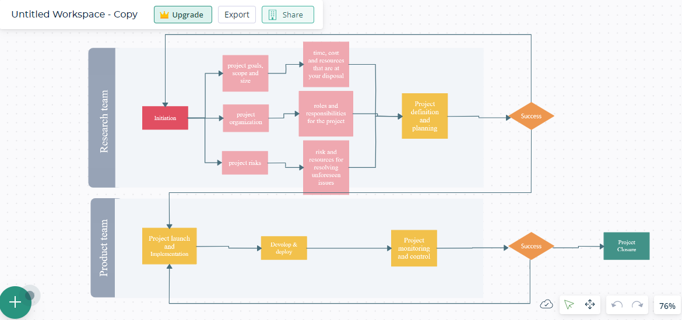

**Question Three**

Define the different types of contracts in software projects

In project management there are three primary types of contracts. Depending on the type of project you’re creating an agreement for and how payment will occur, one of these is the best starting point for drawing a legal framework of the working relationship.

Fixed price (FP) contracts

Fixed price contracts are useful when the scope of the project is clearly defined and easy to understand. Since the parameters of the project are clearly outlined from the outset, the seller or supplier can provide a definitive price quote for the work. As the name suggests, the price is fixed and cannot be altered (without making formal contract amendments) once the buyer agrees to the terms and conditions. FP contracts are considered lump sum contracts because there is one price to be paid upon project completion. There are a few types of FP contracts, including:

* Firm fixed price contract
* Fixed price incentive fee
* Fixed price with economic price adjustment

Time and material (T&M) contracts

T&M contracts are a good choice for buyers who aren’t sure exactly what they want from the outset of the project. With a T&M contract, the buyer contracts the seller based on rates for variables such as materials used and hours or days worked. The contract should include all rates with possible markups on the cost of materials. Once the contract is signed, the agreed upon rates remain in place throughout the course of the project and are used to calculate the final amount the buyer owes the supplies based on the work they do.

Cost reimbursable (CR) contracts

A CR contract is often the best choice when there’s little information for all parties starting out on a project. For example, if it’s a research or development initiative, the CR model removes the need to set fixed rates for work that is difficult to predict or foresee. Instead, the buyer fronts the costs for whatever materials, products or labor is necessary to see the project through to completion.

The responsibility falls solely on the buyer, guaranteeing the supplier that all material costs plus a fee for their services will be covered. In the case of CR contracts, the buyer needs to closely monitor the expenses of the project because there is no obligation on the part of the seller or supplier to keep costs down to stay within a budget. All costs incurred within the scope of work fall on the buyer. The various types of CR contracts are:

* Cost plus percentage of cost
* Cost plus fixed fee
* Cost plus incentive fee
* Cost plus award fee